

**- Faculty of Computer and Information Sciences –**

**- AIN Shams University -**

**HCI - SC**

**-----------------------------------------------------------**

**ECG-BASED-AUTHENTICATION-INTERFACE**

**TEAM INFROMATION: SC-35**

|  |  |  |
| --- | --- | --- |
| **القسم** | **رقــــم الجلوس** | **الأســـــــم** |
| **SC** | **20201700483** | **عبدالرحمن محمد عزازى محمد** |
| **SC** | **20201700204** | **جنه ايمن طلعت مصطفي** |
| **SC** | **20201701055** | **اسراء سعد عبدالحميد سعيد** |

**- Under Supervision -**

**Dr. Manal Tantawi**

**TA. Manar Sultan**

**Main idea**

Ecg-Based-Authentication-Interface that can recognize Authorized Persons from its ECG After result from Classifier based on fiducial features extracted from Signal ..

ECG signals have 11 main points differ from person to each other ..

**Data Preparation**

* **dataset**

**We have obtained 4 ECG signals for 4 different healthy subjects from PTB database. The data is split into 80% for training and 20% for testing, The description of the data is:**

|  |  |
| --- | --- |
| **Number of signals** | **4** |
| **Sampling frequency** | **1000** |
| **Signal Length** | **120012** |
| **Number of channels** | **15** |

**Data Preprocessing :**

**READ DATA:**

Records was in types of “.atr , .dat , .hea”, so we used **wfdb.rdsamp** method in **wfdb** library that take location of all signals and range of samples from 0 to “Specific Range=1000” and number of channels=15 ‘’in case our data read channel[1]“ and is signals and before preprocessing:

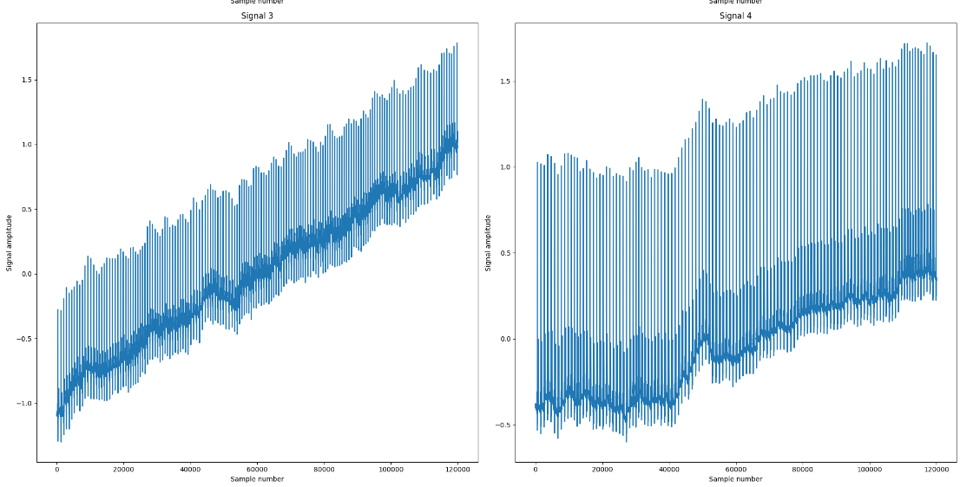 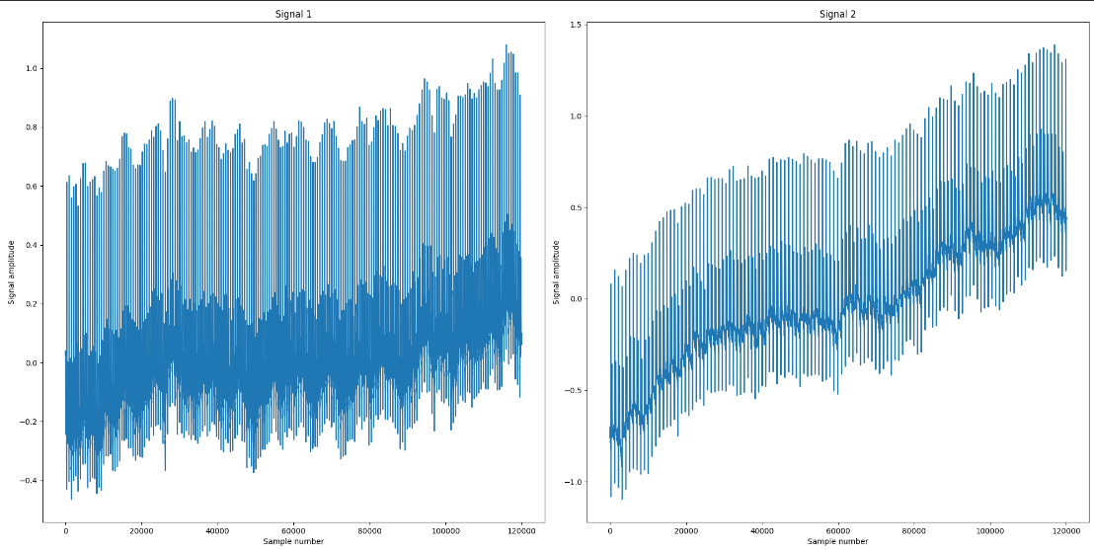

And this is plot after 1.5 second :

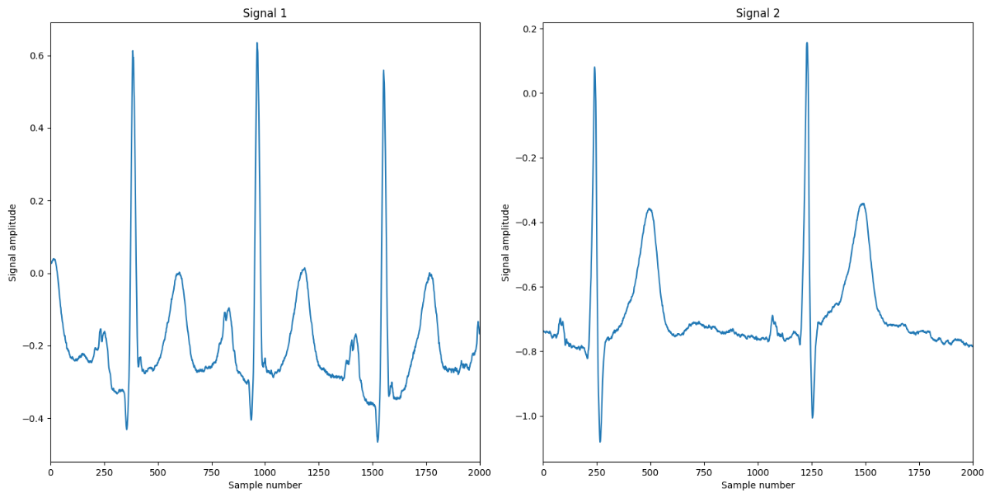 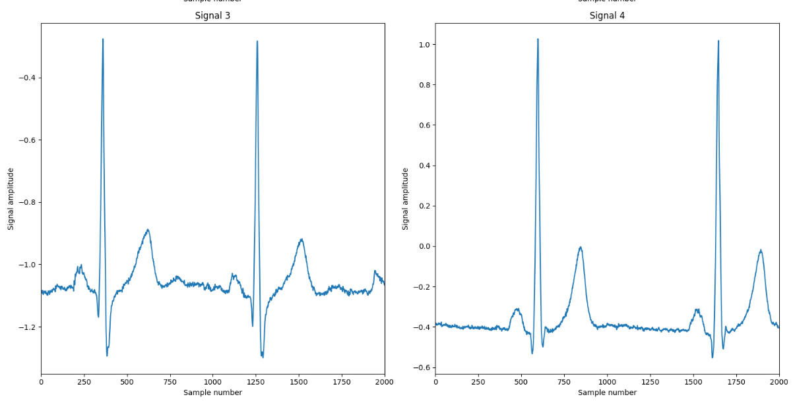

* **Preprocessing**

**We have worked on only one channel (ii).**

* + **Filtering**

ECG data contains noise from multiple sources (e.g., Baseline wander, Power line interface).

* + **Differentiation**
  + **Squaring**
  + **Moving-window integration**
  + **Thresholding**

**We have used a simple Butterworth filter with cut-off frequencies between [1 – 40] Hz, which is the ECG spectrum, to remove the noise.**

After Preprocessing:

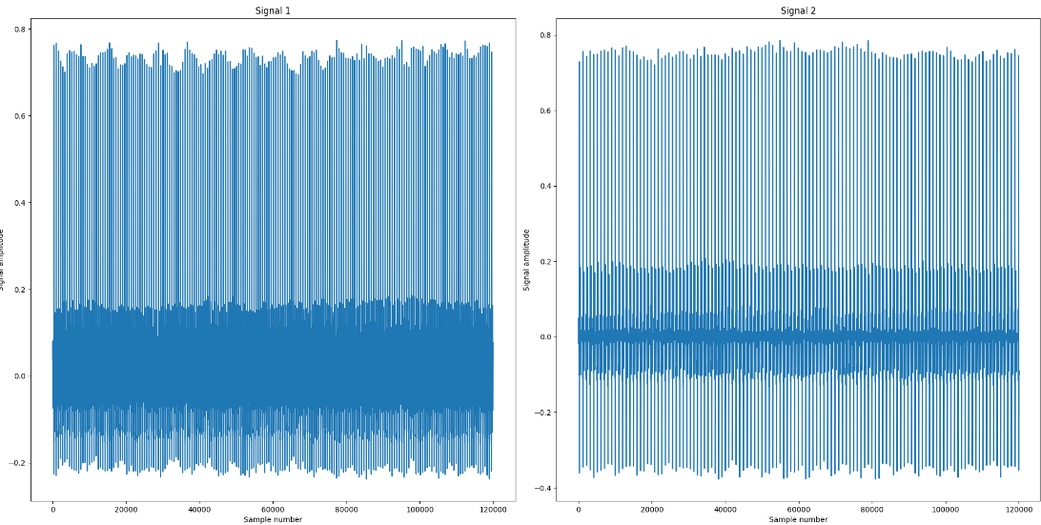

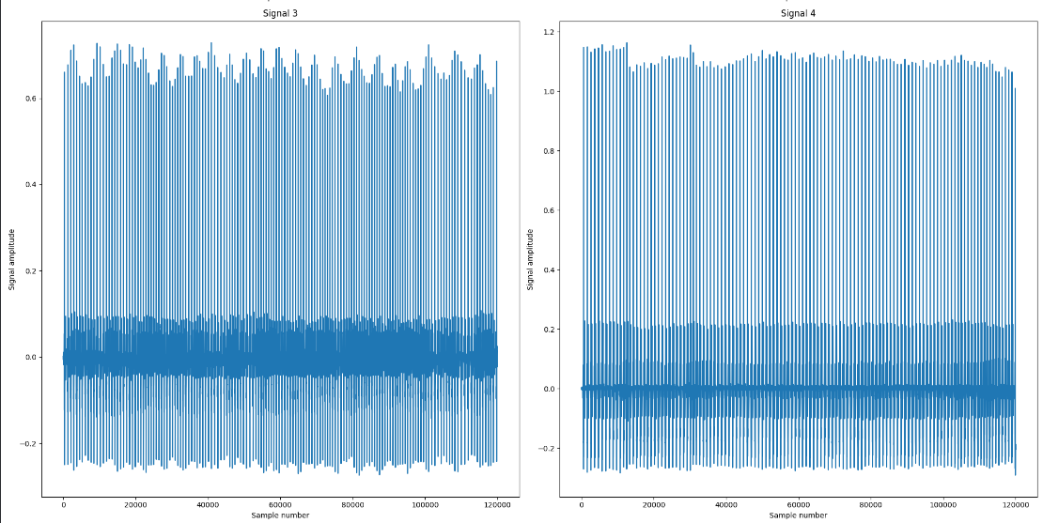

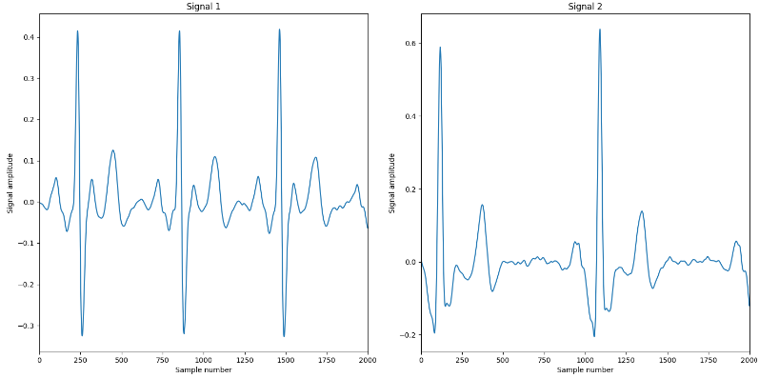

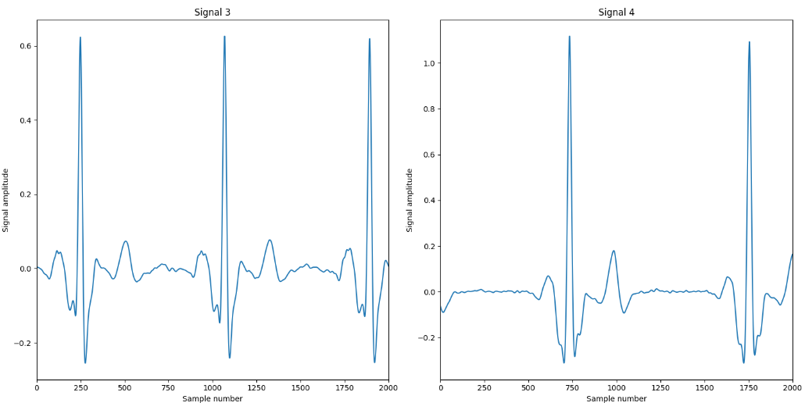

**Features Extraction:**

**Function: fiducial_features_extraction(filtered_signals)**

**Description:**

This function extracts fiducial features from ECG signals to characterize heartbeat patterns.

**Parameters:**

filtered_signals: List of filtered ECG signals.

**Returns:**

features: Extracted fiducial features.

classes: Corresponding beat classes.

**Feature Extraction Process:**

-R Peak Detection: Locate R peaks in each ECG signal.

-S Peak Detection: Find S peaks in each ECG signal.

-Q Peak Detection: Identify Q peaks in each ECG signal.

-T Peak Detection: Identify T peaks in each ECG signal.

-P Peak Detection: Find P peaks in each ECG signal.

*Calculate Waves Onset and Offset: Determine onset and offset of each wave (P, Q, R, S, T) in each ECG signal.

*Extract Features: Calculate various features from fiducial points (P, Q, R, S, T) for each beat:

-QT duration

-PQ duration

-PR duration

-PS duration

-PT duration

-QS duration

-QR duration

-RS duration

-RT duration

-RP amplitude

-RT amplitude

-TP amplitude

**Classifcation :**

We have tried multiple classifiers with different parameters for each of them to get the best results for each class:

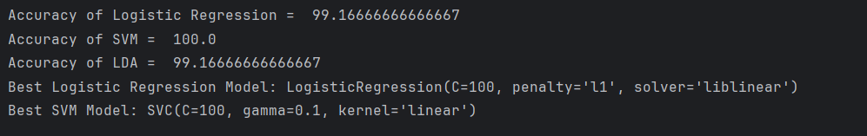

And The best classifer and best parameters is SVM : SVC(C=100, gamma=0.1, kernel='linear')

**GUI :**

We have tried unseen data to test similarty of input singals and the four our patients :

And we test four Patients “3 is already must matched and another 3 must unmatched”

